Casino Brawyal - Version 0.1

Summary
Casino Brawyal is a slot-machine-based roguelike battler where players control unique heroes, using abilities powered by slot machine spins to defeat enemies.
The player starts as Ace—a charming dagger and card slinger seeking revenge against the casino boss who wronged him, Mr. Moneyman. Along the way, Ace gathers resources, unlocks new abilities, and battles enemies until reaching and facing the final boss.
As players progress, they can unlock additional characters and uncover their individual storylines.
In Casino Brawyal, a slot machine generates suit symbols that yield matching casino chips, which are then used to activate the player's abilities. After the player spins and executes their turn, the enemies respond with their own attacks. Winning encounters earns rewards to upgrade the hero and the slot machine; losing ends the run.
This version focuses exclusively on Act I, featuring an early build of Ace and the core implementation of the game systems.

Main Game Loop
- Encounters: Challenges encountered on the path to the boss. There are three types of encounters:
  - Combat - The player uses abilities to defeat enemies. Winning yields rewards; losing ends the run.
  - Hard Combat - A higher-difficulty battle offering greater rewards. Hard combats come in two variants (chosen randomly):
    - Buffed Enemies: Enemies gain +25% Health and deal +25% Damage.
    - Advanced Encounters: The player faces an enemy lineup normally reserved for a later stage.
After completing any combat encounter, the player claims Rewards.
  - Story - A narrative scenario where the player makes a choice, leading to distinct rewards or consequences.
  - Rest - The character restores 30% of their maximum health or receives rewards.
  - Treasure - A direct reward node where the player receives an item without making a choice.
  - Shop - The player spends collected rewards to purchase items and upgrades.
- Choice: The player selects their next encounter from two randomized options.

This loop repeats for 9 encounters. Following the 9th encounter, the final Choice step presents a single mandatory option: the Boss Fight. Defeating the boss clears the run!

Combat
Combat is the primary encounter type. The player's hero battles enemies to earn rewards and advance through the act.
To perform actions, they use a slot machine to spin symbols, generating suit chips that activate hero abilities.

Combat progresses over a series of rounds consisting of three distinct steps:
- Enemy Intent + Machine Spin
- Abilities Assignment
- Enemy Phase

1. Enemy Intent & Machine Spin
At the start of each round, two actions occur simultaneously:
- Enemy Intent: Enemies display their intended actions above their heads. Displays follow this layout from left to right:
  - Debuffs: Icons representing debuffs the attack will inflict, alongside their intensity or duration.
    - Example: [Muscle + Down Arrow Icon] 2 indicates a Weak debuff lasting 2 turns.
  - Damage: The total incoming damage value.
    - Structure: [Instances] x [Damage per Hit]. Example: 2x3 = 2 hits of 3 damage each. If Instances = 1, only the Damage per Hit appears.
- Machine Spin: The slot machine begins with 3 reels containing one of each suit symbol (Spade, Club, Heart, Diamond). Reels resolve from left to right, generating chips based on the resulting combination:
  - All Unique Symbols: Grants 1 chip corresponding to each spun symbol.
  - Pairs: For every exact pair of matching symbols, the player receives 3 chips of that suit.
  - Three or More Matching: If 3 or more matching symbols land, the player receives chips equal to the number of matched symbols + 2 bonus chips.

2. Ability Assignment
Once chips are generated, the player assigns them to abilities to trigger their effects. Each ability requires specific quantities and types of chips.
- Targeting: Tap any unit to select them as a target. If an enemy has Taunt, players must target that enemy.
  - Selected targets persist across turns until manually changed.
  - If an enemy gains Taunt, player targeting automatically shifts to them.
  - The target automatically shifts to the lowest health available enemy on enemy death, and automatically chooses the target if there’s only one.
- Activation: Place the required chips into an ability's designated slots. Once all slots are filled, the skill triggers against the selected target.
- Persistence: Chips can be slotted into eligible abilities in any order. Partially filled abilities retain their assigned chips until fully filled and triggered.
  - Slotted chips carry over between combat rounds, but clear when the encounter ends.
- Discard: Any unassigned chips remaining at the end of the phase are discarded.

3. Enemy Phase
After the player completes their turn, enemies execute their announced intentions in order from left to right.
If the player survives the enemy attacks, the round ends and returns to the Enemy Intent & Machine Spin phase. If the hero's health drops to 0, the game ends in defeat.

Rewards
Defeating an encounter grants the following rewards:
- Coins: Rewards a randomized gold amount calculated as (Encounter Number x 8) to (Encounter Number x 12).
- Ability Choice: Select 1 out of 2 unowned abilities to add to the hero's pool.
- Relic (Hard Combat Only): Grants 1 random unowned relic.

Story
In Story encounters, players read a brief narrative scene and select one of 2–4 choices, each offering distinct benefits or drawbacks.
Each Story encounter includes the following elements:
- Header: The encounter title.
- Description: A narrative paragraph establishing the setting and situation.
- Image: An illustration depicting the scene.
- Choices: Interactive options containing:
  - Choice Header: A concise title for the option.
  - Rewards / Effects: A summary of the outcomes or rewards associated with the choice.

Rest
When visiting a Rest node, the player chooses one of two options:
- Rest: Restores 30% of max health.
- Reward: Grants one random reward selected from the primary Rewards pool.

Treasure
Grants 1 random unowned relic from the available relic pool.

Shop
In the Shop encounter, players spend gold to purchase items, upgrades, and abilities. Stocking options include:
- Extra Reel:
  - Price: 100 Coins (+50 Coins per previously purchased reel)
  - Increases machine reels by 1 (up to 8 total). Added reels start as basic reels with the four default suit symbols.
- Symbol Stickers (x4):
  - Price: 20 Coins (+5 Coins x Encounter Number)
  - Stickers can be applied to reel slots via the Layout tab to replace an existing symbol. One sticker is available per suit.
- Relics (x3):
  - Price: 150–200 Coins (Randomized)
  - Offers 3 random unowned relics from the available pool.
- Abilities (x4):
  - Price: 50–100 Coins (Randomized)
  - Offers 4 unowned abilities from the available pool.
Note: If the pool of available relics or abilities runs out, corresponding shop slots will remain empty.

Boss Fight
A climax battle at the end of the act. In this version, Act I is the sole act, making the Boss Fight the final challenge of the game.

Choice
Players select from 2 encounter options according to the following progression rules:
- Encounter #1 is always a standard Combat (starts automatically after character selection).
- Encounter #10 offers a single choice: Boss Fight.
- Rest nodes appear exclusively as options for Encounter #4 and Encounter #9.
- Shops appear up to 3 times per run and cannot appear consecutively. The final Shop option always appears at Encounter #9.
- Hard Combats only appear starting after Encounter #3.
- Treasure nodes appear up to 2 times, cannot occur consecutively, and only appear after Encounter #2.

Characters

Ace
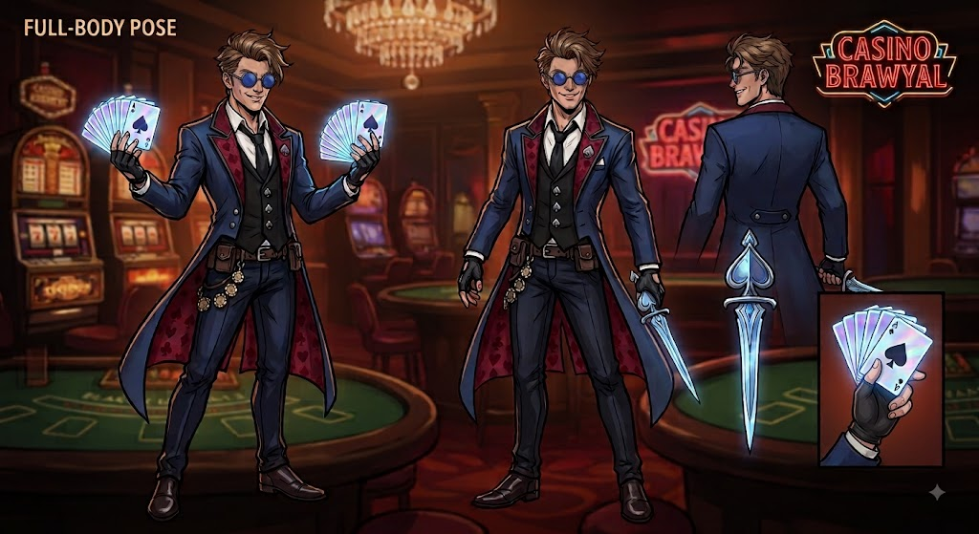
Key Characteristics: Fast-paced, backline targeting, Spade-synergy focus.
Weapons: Cards and Dagger.
Description: A dashing debonair, swashbuckler, and gambler who entered the casino to settle a score with its corrupt owner.
Ace specializes in matching specific suit symbols to key skills. Most of his abilities grant bonus effects when activated using designated suit chips. He also possesses color-manipulation skills to consistently align chip combinations.

Enemies

Menagerie
XXX

Encounters

Combat
XXX

Story
XXX

Event
XXX

Reward
XXX

Visuals

Assets
XXX

Animations
XXX

Sounds
XXX

